******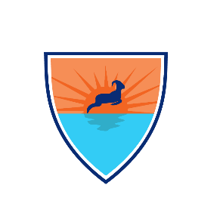Sea Ram, LLC Presents PITA**

The Hill School

717 E High Street,

Pottstown, PA, USA 19464

**Distance to NASA Johnson Space Center’s Neutral Buoyancy**: 1534 miles

**History of MATE Participation**: This is our second year entering MATE and, during our first year, we placed third place in Pennsylvania regionals and competed at the internationals.

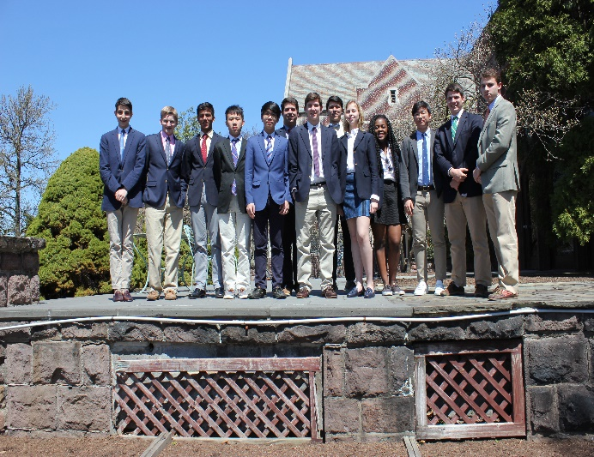**Sea Ram Robotics (From left to right)**

Damian Baraty (Team Captain / Instructor)

Tim Jump (Faculty Adviser)

Robert Steinman (Faculty Adviser)

Harrison Wolf (Software Intern / 9th)

Harrison Nicholls (CFO / 9th)

Manshu Sharma (CEO / 11th)

Alan He (Design Engineer / 10th) b

David Park (Robotic Arm Engineer / 10th)

Jake Trombley (Relations Coordinator / 12th)

Alex Rakos (Graphics Designer / 11th)

Aaron Lethers (Graphics Designer / 12th)

Ceylin Sener (Communications Director / 9th)

Breana McDonald (Project Manager / 12th)

Kevin Kim (CDO / 12th)

Erik Patrinostro (Electrical Engineer / 11th)

Dylan Spector (CTO / 12th)

Andy Donato (System Specialist / 11th)

**ROV Tech Specs**

**Name: PITA**

**Price:**

**Hours of Contribution (hrs):** 384

Harrison W., and Harrison W. – 60

Alan, David, Jake, Alex, Aaron, Breana, and Erik – 42

Ceylin, and Kevin – 120

Manshu, Dylan, and Andy – 162

**Safety Features**

* **Rigorous Water Proof System –** Every on board electronic device or exposed junction goes to the pressure tube to ensure safe handling and electron transfer.
* **Quick Connect** – Easy replacement of motors without any need of interior exposure.
* **T-100 Thrusters by Blue Robotics™ –** Industry standardized and ©MATE approved that have sealed electronics and protective shroud to prevent electrical shocks.

**Special Features**

* **Robotic Arm** – Double hinged and two finger grips that allow easier underwater tasks.
* **Easy-to-use Joystick** – Logitech™ Extreme 3D Pro Joystick provides an intuitive control interface. The joystick applies to our robot’s unique five degrees of freedom.
* **Wide Angle Camera System** – Simultaneous displays of the robot’s surroundings.
* **Laser-cut Chassis –** Delrin® engineered chassis for lightweight and superior stability.
* **Watertight Enclosure & Dome End** – Safe container with holes for electronics and wires.
* **Subsea Buoyancy Foam** – Machined and coated to provide the perfect float for the robot.
* **Efficient Electronics –** Easy to configure and user friendly electronics system.